**CITY OF JERSEY CITY**

Department of Housing, Economic Development & Commerce

Division of City Planning

Interdepartmental Memorandum

DATE: 4/26/22

TO: Planning Board Commissioners

FROM: Cameron Black, Senior Planner, AICP, PP

RE: Case # P22-002

246 Clinton Avenue, Block: 18302 , Lot 51.02

Site Plan Amendment with “c” variances

**APPLICATION SUMMARY**

Variance and site plan approval was previously granted by this Board in Application P20-006. Applicant seeks to amend the approved site plan by changing the side yard setbacks to provide 3'1" side yard setback on both sides for egress purposes. Applicant seeks to amend both units from a 2 to 3 bedroom. Applicant further seeks to amend the site plan by adding a roof deck for the 2nd floor unit and to slightly increase the total square footage from 3,272 to 3,343 sf, add green rood trays to the rood deck and adding a 2' overhang in the front of the building for the 2nd and 3rd floor. No other changes and no new variances are being requested.

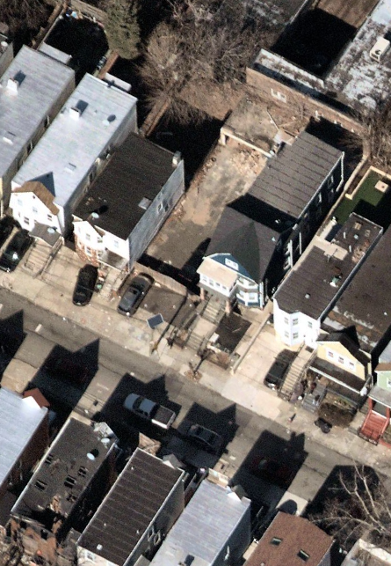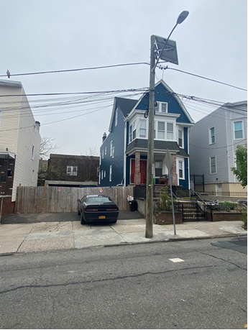

**Applicant’s Site Outlined in Red**

**“c” VARIANCES/DEVIATIONS FOR SITE PLAN**

|  |  |  |  |
| --- | --- | --- | --- |
| **#** | **REQUIREMENT** | **APPROVED** | **PROPOSED** |
| 1 | Minimum rear yard 20’ | 15’ rear yard | 15’ rear yard |

**Photo A – Site Looking North**

**SEE APPENDIX A FOR FINDINGS NEEDED FOR “c” VARIANCE RELIEF**

**STAFF RECCOMENDS APPROVAL WITH THE FOLLOWING CONDITIONS:**

1. The architect of record, shall be retained during construction and shall submit a signed and sealed affidavit affirming that site construction was consistent with approved plans prior to the issuance of any Certificate of Occupancy.
2. All materials and color selections shall be as shown on the final plans.
3. No changes to the facade and site design, including materials as well as any changes that may be required by the Office of Construction Code, shall be permitted without consultation and approval by the planning staff.
4. All testimony given by the Applicant and the expert witness in accordance with this application shall be binding.
5. All street trees and landscaping shall be installed in accordance with 345-66 and the City’s Forestry Standards, prior to an issuance of a Certificate of Occupancy.

**APPENDIX A**

**FINDINGS NEEDED FOR “c” VARIANCE RELIEF**

The following findings are required for “c” Variance Relief:

1. Hardship “C1” Variance Standard under N.J.S.A. 40:55(D)-70(c)(1):
   1. Pertinent information: Exceptional narrowness, shallowness, or shape of the property, exceptional topographical conditions, and/or other exceptional situations.
   2. Based on this information, the strict application of the Ordinance would result in exceptional difficulties to, and undue hardships upon, the developer of such property.
   3. The conditions causing hardship are peculiar to the subject property, and do not apply generally to other properties in the same district.
   4. Other means to cure the deficiency (such as purchase or sale of property) do not exist, or are unreasonable or impracticable.
   5. The variance requested is the reasonable minimum needed.
2. Flexible “C2” Variance Standard under N.J.S.A. 40:55D-70(c)(2):
   1. The justifications must relate to a specific piece of property;
   2. The purposes of the Municipal Land Use Law would be advanced by a deviation from the zoning ordinance requirement;
   3. The variance can be granted without substantial detriment to the public good;
   4. The community benefits of the deviation would substantially outweigh any detriment and;
   5. The variance will not substantially impair the intent and purpose of the zone plan and zoning ordinance.

**NEGATIVE CRITERIA**

**No relief may ever be granted unless it can be done**

1. **without substantial detriment to the public good, and**
2. **without substantially impairing the intent and purpose of the zone plan and zoning ordinance**

**1) Substantial detriment to the public good – Balancing Requirement.**

The focus of this first prong of the negative criteria is on the variance’s effect on the surrounding properties. The board must weigh the zoning benefits from the variance against the zoning harms. In many instances, conditions of approval address the negative criteria standard and help to mitigate the impact of the variance.

**2) Substantial impairment to the intent and purpose of the zone plan and ordinance.**

The focus of this second prong of the negative criteria is on the power to zone based on ordinance and not variance

